APRIL & MAY DRIVE CARLISLE AREA FAMILY LIFE CENTER
Please support the Carlisle Area Family Life Center by donating any of the items listed and bring them to the April and May Membership Meetings

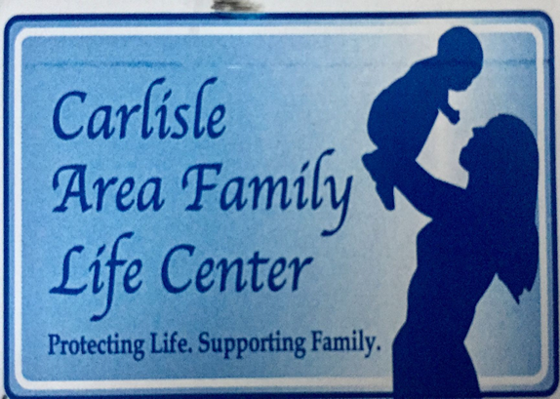
The Carlisle Area Family Life Center is a nonprofit and non- judgemental organization.  The Center’s mission is to support, educate and give practical assistance, in a loving way, to families in need by providing positive alternatives to abortion and by enabling them to make informed decisions regarding their lives and the lives of their unborn children.  The Center relies totally on donations to support its work to reach out to women and families in the community. | FOR BABY  - Baby Formula (Similac Advance, Soy and Sensitive (powdered)  - Diapers (Sizes 3,4,5,6 and Pull-Ups)  - Disposable Baby Wipes  - Disposable Baby Wipes  - Receiving Blankets (Gender Neutral)  - Baby Shampoo and Body Wash  - Crib Sheets  - Diaper Cream  - Diaper Bags  - Bottles (any kind)  - Pacifiers  - Hooded Towels  - Washcloths  - Small Toys  - Monetary Donations or Gift Cards  FOR MOMMY  - Yoga Pants (Non-Maternity kind – Sizes M, L, XL)  Will also accept gently used maternity and children’s clothes (Newborn – 4T) and baby gear and equipment (NO CAR SEATS OR BUMPER GUARDS).

